**Analog final lab assignment**

|  |  |
| --- | --- |
| **ID** | **NAME** |
| **6338** | Ahmed Mohamed ahmed ali |
| **6071** | Ahmed Wael Mohamed |
| **6297** | Adel Ashraf Mohamed |
| **6160** | Mazen Medhat Farid |
| **6646** | Ahmed Tarek Ahmed |
| **4629** | Mahmoud Osama |

**Experiment 1:**

**Code:**

clc

clear

close all

**Read the audio file and get its sampling frequency**

[y, F] = audioread('eric.wav');

ty = length(y)/F;

t = linspace(0, ty, length(y));

**Input signal conversion to frequency domain (to apply ideal LPF)**

z = fftshift(fft(y));

f = linspace(-F/2, F/2, length(y));

figure

plot(f, abs(z),'g');

title('Original Signal in Frequency Domain');

**generate ideal filter**

% Searching for indices where f = -4000 and f = 4000

for i = 1:length(f)

if (abs((f(i)+4.0000e+3)) < 0.01)

index1 = i;

end

if (abs((f(i)-4.0000e+3)) < 0.01)

index2 = i;

break;

end

end

% Generating a rect from index1 to index2

range = index2-index1;

step = [zeros(1, index1) ones(1, range) zeros(1, length(f)-index2)];

step = step.';

**Multiplying input signal by rect to eliminate frequencies other than 4k**

yfilteredFreq = step.*z;

yfilteredFreqAbs = abs(step.*z);

figure

plot(f, yfilteredFreqAbs,'g');

xlim([-15000 15000]);

title('Filtered Signal in Frequency Domain');

% Converting the filtered signal to time domain to be modulated

yfiltered = ifft(fftshift(yfilteredFreq));

figure

plot(t, yfiltered,'r');

title('Filtered Signal in Time Domain');

% Signal after low pass filter

sound(yfiltered, F);

pause(9);

**Filtered signal resampling**

maxAmplitude = max(yfiltered);

yfiltered = resample(yfiltered, 500000, F);

yfiltered = yfiltered.';

interval = length(yfiltered);

**DSB-SC Modulation and Demodulation**

**Modulation**

t = linspace(0, ty, interval);

dsbsc = 5*cos(2*pi*100000*t).*yfiltered;

figure

plot(t, dsbsc,'r');

title('Modulted DSB-SC Signal in Time Domain');

zmsc = abs(fftshift(fft(dsbsc)));

fmsc = linspace(-500000/2, 500000/2, length(dsbsc));

figure

plot(fmsc, zmsc,'g');

xlim([-150000 150000]);

ylim([0 300]);

title('Modulated DSB-SC Signal in Frequency Domain');

**Demodulation**

dsbscEnvelope = abs(hilbert(dsbsc));

dsbscEnvelope = resample(dsbscEnvelope, F, 500000);

t = 0:1/F:length(dsbscEnvelope)/(F);

t = t(1:end-1);

figure

plot(t, dsbscEnvelope,'r');

title('Demodulted DSB-SC Signal in Time Domain');

zdsc = abs(fftshift(fft(dsbscEnvelope)));

fdsc = linspace(-F/2, F/2, length(dsbscEnvelope));

figure

plot(fdsc, zdsc,'g');

xlim([-8000 8000]);

ylim([0 1500]);

title('Demodulated DSB-SC Signal in Frequency Domain');

sound(dsbscEnvelope, F);

pause(9);

**Coherent detection**

dsbsc0 = awgn(dsbsc,0);

dsbsc10 = awgn(dsbsc,10);

dsbsc30 = awgn(dsbsc,30);

t = linspace(0, ty, length(dsbsc));

vpe = dsbsc.*cos((2*pi*100000*t) + deg2rad(20));

vfe = dsbsc.*cos(2*pi*100100*t);

v0 = dsbsc0.*cos(2*pi*100000*t);

v10 = dsbsc10.*cos(2*pi*100000*t);

v30 = dsbsc30.*cos(2*pi*100000*t);

v0 = resample(v0, F, 500000);

v10 = resample(v10, F, 500000);

v30 = resample(v30, F, 500000);

vpe = resample(vpe, F, 500000);

vfe = resample(vfe, F, 500000);

zsc0 = fftshift(fft(v0));

zsc10 = fftshift(fft(v10));

zsc30 = fftshift(fft(v30));

zscpe = fftshift(fft(vpe));

zscfe = fftshift(fft(vfe));

fsc = linspace(-F/2, F/2, length(v0));

for i = 1:length(fsc)

if (abs((fsc(i)+4.0000e+3)) < 0.01)

index1 = i;

end

if (abs((fsc(i)-4.0000e+3)) < 0.01)

index2 = i;

break;

end

end

range = index2-index1;

step = [zeros(1, index1) ones(1, range) zeros(1, length(fsc)-(index2))];

dsbscCoherent0 = step.*zsc0;

dsbscCoherent10 = step.*zsc10;

dsbscCoherent30 = step.*zsc30;

dsbscCoherentpe = step.*zscpe;

dsbscCoherentfe = step.*zscfe;

figure

plot(fsc, abs(dsbscCoherent0),'g');

title('Demodulated DSB-SC Signal using Coherent Detection with SNR = 0 in Frequency Domain');

xlim([-8000 8000]);

figure

plot(fsc, abs(dsbscCoherent10),'g');

title('Demodulated DSB-SC Signal using Coherent Detection with SNR = 10 in Frequency Domain');

xlim([-8000 8000]);

figure

plot(fsc, abs(dsbscCoherent30),'g');

title('Demodulated DSB-SC Signal using Coherent Detection with SNR = 30 in Frequency Domain');

xlim([-8000 8000]);

figure

plot(fsc, abs(dsbscCoherentpe),'g');

title('Demodulated DSB-SC Signal using Coherent Detection with Phase Error = 20 in Frequency Domain');

xlim([-8000 8000]);

figure

plot(fsc, abs(dsbscCoherentfe),'g');

title('Demodulated DSB-SC Signal using Coherent Detection with Frequency Error = 100 HZ in Frequency Domain');

xlim([-8000 8000]);

dsbscCoherentTime0 = ifft(fftshift(dsbscCoherent0));

dsbscCoherentTime10 = ifft(fftshift(dsbscCoherent10));

dsbscCoherentTime30 = ifft(fftshift(dsbscCoherent30));

dsbscCoherentTimepe = ifft(fftshift(dsbscCoherentpe));

dsbscCoherentTimefe = ifft(fftshift(dsbscCoherentfe));

t = linspace(0, ty, length(dsbscCoherentTime0));

figure

plot(t, abs(dsbscCoherentTime0),'r');

title('Demodulated DSB-SC Signal using Coherent Detection with SNR = 0 in Time Domain');

sound(abs(dsbscCoherentTime0), F);

pause(9);

figure

plot(t, abs(dsbscCoherentTime10),'r');

title('Demodulated DSB-SC Signal using Coherent Detection with SNR = 10 in Time Domain');

sound(abs(dsbscCoherentTime10), F);

pause(9);

figure

plot(t, abs(dsbscCoherentTime30),'r');

title('Demodulated DSB-SC Signal using Coherent Detection with SNR = 30 in Time Domain');

sound(abs(dsbscCoherentTime30), F);

pause(9);

figure

plot(t, abs(dsbscCoherentTimepe),'r');

title('Demodulated DSB-SC Signal using Coherent Detection with Phase Error = 20 in Time Domain');

sound(abs(dsbscCoherentTimepe), F);

pause(9);

figure

plot(t, abs(dsbscCoherentTimefe),'g');

title('Demodulated DSB-SC Signal using Coherent Detection with Frequency Error = 100 HZ in Time Domain');

sound(abs(dsbscCoherentTimefe), F);

pause(9);

**DSB-TC Modulation and Demodulation**

**Modulation**

t = linspace(0, ty, interval);

dsbtc = 2.*maxAmplitude.*(1+(0.5/maxAmplitude).*yfiltered).*cos(2.*pi.*100000.*t);

figure

plot(t, dsbtc,'r');

title('Modulted DSB-TC Signal in Time Domain');

zmtc = abs(fftshift(fft(dsbtc)));

fmtc = linspace(-500000/2, 500000/2, length(dsbtc));

figure

plot(fmtc, zmtc,'g');

xlim([-150000 150000]);

ylim([0 1000]);

title('Modulated DSB-TC Signal in Frequency Domain');

**Demodulation**

dsbtcEnvelope = abs(hilbert(dsbtc));

dsbtcEnvelope = resample(dsbtcEnvelope, F, 500000);

dsbtcEnvelope=dsbtcEnvelope-mean(dsbtcEnvelope);

t = 0:1/F:length(dsbtcEnvelope)/(F);

t = t(1:end-1);

figure

plot(t, dsbtcEnvelope,'r');

title('Demodulted DSB-TC Signal in Time Domain');

zdtc = abs(fftshift(fft(dsbtcEnvelope)));

fdtc = linspace(-F/2, F/2, length(dsbtcEnvelope));

figure

plot(fdtc, zdtc,'g');

xlim([-8000 8000]);

ylim([0 1000]);

title('Demodulated DSB-TC Signal in Frequency Domain');

sound(dsbtcEnvelope, F);

**output:**

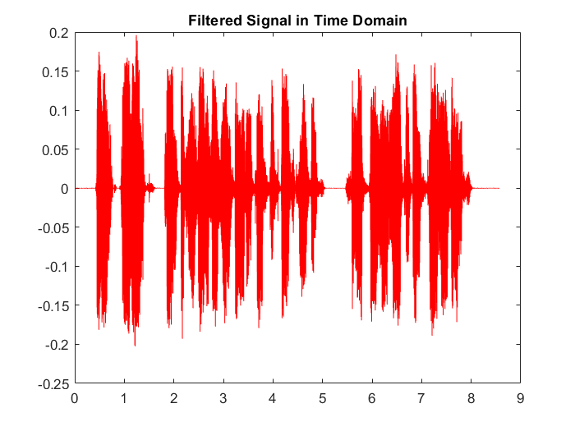

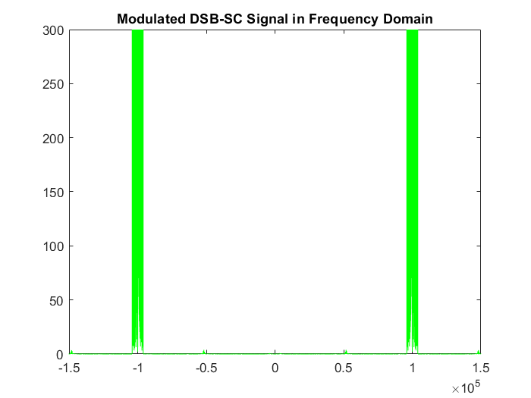

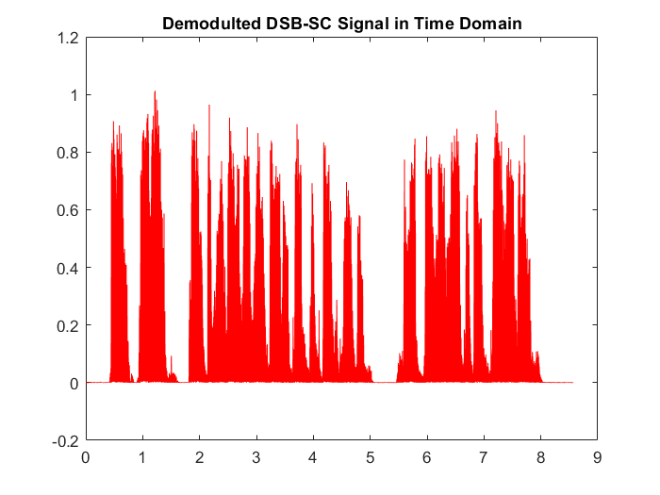

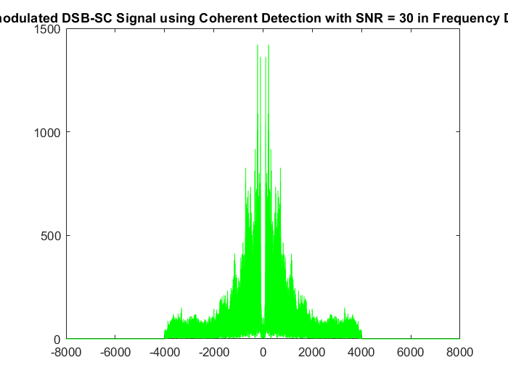

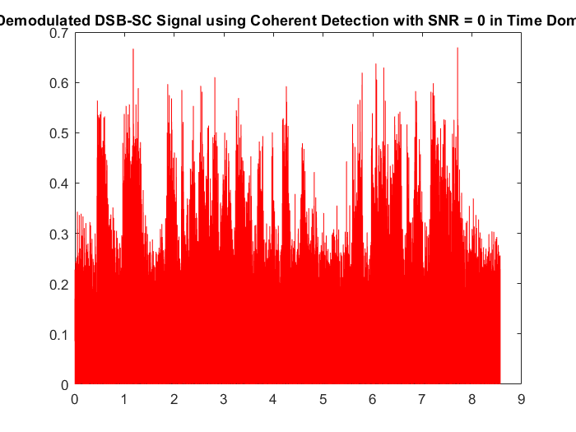

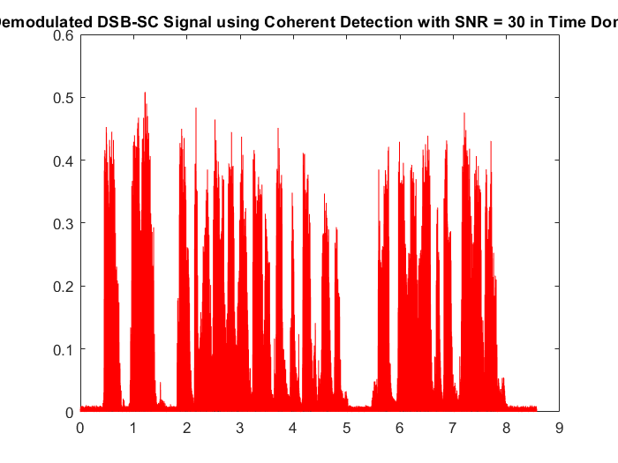

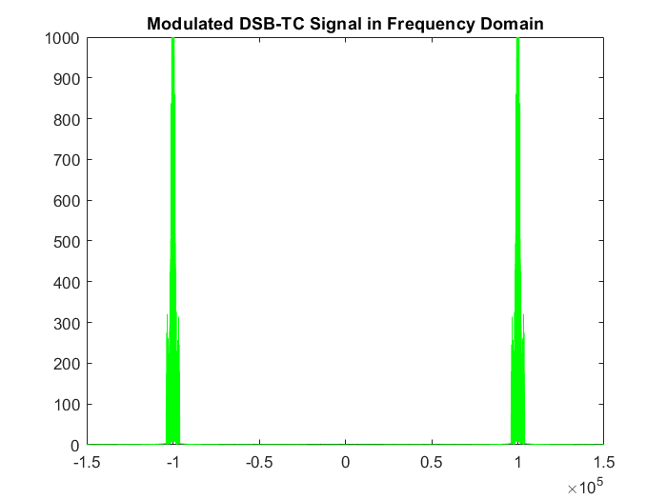

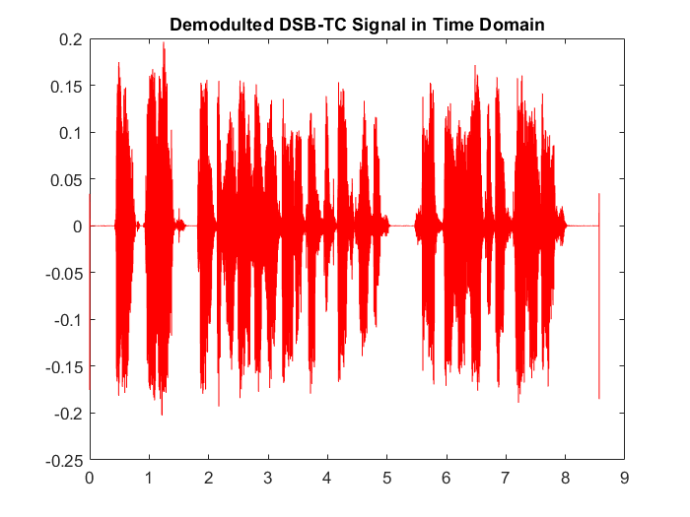

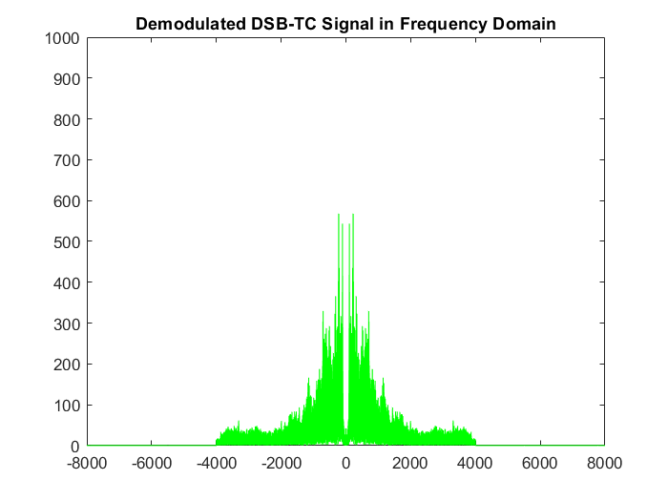

**Experiment Conclusions**

🡪 By using Envelope Detector, we observe that there is more

distortion in case of DSB-SC. DSB-SC should be demodulated by

coherent detection. Envelope Detector can be used to

demodulate DSB-TC.

🡪It is called beat effect

**Experiment 2:**

**Code:**

clc

clear

close all

**Read the audio file and get its sampling frequency**

[y, F] = audioread('eric.wav');

ty = length(y)/F;

t = linspace(0, ty, length(y));

T=linspace(0, ty, length(y));

plot(t,y,'r');

title('Original Signal in Time Domain');

**Input signal conversion to frequency domain**

z = fftshift(fft(y));

zf=abs(z);

f = linspace(-F/2, F/2, length(y));

plot(f,zf,'g');

title('Original Signal in Frequency Domain');

**apply ideal LPF ,Searching for indices where f = -4000 and f = 4000**

for i = 1:length(f)

if (abs((f(i)+4.0000e+3)) < 0.01)

index1 = i;

end

if (abs((f(i)-4.0000e+3)) < 0.01)

index2 = i;

break;

end

end

%Generating a rect from index1 to index2

range = index2-index1;

step = [zeros(1, index1) ones(1, range) zeros(1, length(f)-index2)];

step = step.';

**Multiplying input signal by rect to eliminate frequencies other than 4k**

yfilteredFreq = step.*z;

yfilteredFreqAbs = abs(step.*z);

figure

plot(f, yfilteredFreqAbs,'g');

xlim([-4.5 4.5].*10^3)

title('Filtered Signal in Frequency Domain at 4KHZ (ideal filter)');

**Converting the filtered signal to time domain to be modulated DSB-SC**

yfiltered= ifft(ifftshift(yfilteredFreq));

yfiltered=yfiltered.';

figure

plot(T,yfiltered,'r');

title('Filtered Signal in Time Domain at 4KHZ (ideal filter)');

sound(yfiltered, F);

pause(9);

%Filtered signal resampling

maxAmplitude = max(yfiltered);

yfiltered = resample(yfiltered, 500000, F);

interval = length(yfiltered);

**DSB-SC Modulation**

t = linspace(0, ty, interval);

carrier=cos(2*pi*100000*t);

dsbsc =carrier.*yfiltered;

figure

plot(t, dsbsc,'r');

title('Modulted DSB-SC Signal in Time Domain');

zm_sc=fftshift(fft(dsbsc));

zmsc = abs(fftshift(fft(dsbsc)));

fmsc = linspace(-500000/2, 500000/2, length(dsbsc));

figure

plot(fmsc, zmsc,'g');

xlim([-150000 150000]);

ylim([0 1000]);

title('Modulated DSB-SC Signal in Frequency Domain');

xlim([-12 12].*10^4)

**remove USB to get SSB using ideal filter**

for i1 = 1:length(dsbsc)

if (abs((fmsc(i1)+1.0000e+5)) < 0.1)

idx1 = i1;

end

if (abs((fmsc(i1)-1.0000e+5)) < 0.1)

idx2 = i1;

break;

end

end

%Generating a rect from idx1 to idx2

range1 = idx2-idx1;

step1 = [zeros(1, idx1) ones(1, range1) zeros(1, length(fmsc)-idx2)];

LSB_Frequency = step1.*zm_sc;

LSB_FAbs = abs(step1.*zm_sc);

figure

plot(fmsc, LSB_FAbs,'g');

xlim([-150000 150000]);

ylim([0 1000]);

title('Obtain LSB in Frequency Domain using from DSB-SC (ideal filter)');

xlim([-12 12].*10^4)

LSB_time = ifft(ifftshift(LSB_Frequency));

**demodulation of SSB using coherent detector ideal filter**

SSB_SC = LSB_time.*carrier;

SSB_SC = resample(SSB_SC,F,500000);

SSB_SC_ff= fftshift(fft(SSB_SC)) ;

%ideal lpf to get signal in frequency domain

SSB_SC_ff=SSB_SC_ff(1:end-1);

SSB_SC_ff =SSB_SC_ff.*step';

SSB_SC_time =ifft(ifftshift(SSB_SC_ff)) ;

signal_frequency_domain= fftshift(fft(SSB_SC_time));

figure

plot(T,SSB_SC_time,'r');

title('recieved LSB in Time Domain (ideal filter)');

figure;

plot(f,abs(signal_frequency_domain),'g');

title('recieved LSB in Freqency Domain (ideal filter)');

xlim([-4.5 4.5].*10^3)

sound(SSB_SC_time,F);

pause(9);

**remove USB to get SSB using butter filter**

**Butterworth filter BPF to get LSB**

fnorm = 500000/2;

BW_fitler=(500000*4000)/48000;

[numerator, denomenator] = butter(4,[100000 100000+BW_fitler]/fnorm,'bandpass');

Filter_DSB = filter(numerator, denomenator, dsbsc);

LSB_Butter = Filter_DSB.*carrier;

plot(fmsc,abs(fftshift(fft(Filter_DSB))),'g');

title('Obtain LSB in Freqency Domain (Butter filter)');

%down sample butter filter

LSB_down =resample(LSB_Butter,F,500000);

LSB_down =LSB_down(1:end-1);

lsb_freq=abs(fftshift(fft(LSB_down)));

**Butterworth filter LPF to get LSB after demodulation**

[numerator, denomenator] = butter(4,4000/(F/2));

LSB_LPF_Time = filter(numerator, denomenator, LSB_down);

LSB_LPF_Freq = fftshift(fft(LSB_LPF_Time));

figure

plot(LSB_LPF_Time,'r');

title('recieved LSB in Time Domain (butter filter)');

figure

plot(f,abs(LSB_LPF_Freq),'g');

title('recieved LSB in Freqency Domain (butter filter)');

xlim([-4.5 4.5].*10^3)

%NOISE is added to signal

noised_signal_0 = awgn(LSB_time,0, 'measured');

noised_signal_10 = awgn(LSB_time,10,'measured');

noised_signal_30 = awgn(LSB_time,30,'measured');

noised_signal_0=noised_signal_0';

noised_signal_10=noised_signal_10';

noised_signal_30=noised_signal_30';

carrier=carrier.';

LSB0 = noised_signal_0.*carrier;

coherent0 = resample(LSB0,F,500000);

coherent0 = coherent0(1:end-1);

coherentFreq0 = fftshift(fft(coherent0));

coherentFilter0 = step.*coherentFreq0;

coherentTime0 = ifft(ifftshift(coherentFilter0)) ;

figure;

plot(T,coherentTime0,'r');

title('recieved LSB in Time Domain (ideal filter) with noise SNR=0');

figure;

plot(f,abs(coherentFilter0),'g');

title('recieved LSB in Freq Domain (ideal filter) with noise SNR=0');

xlim([-4.5 4.5].*10^3)

sound(real(coherentTime0),F);

pause(9);

LSB10 = noised_signal_10.*carrier;

coherent10 = resample(LSB10,F,500000);

coherent10 = coherent10(1:end-1);

coherentFreq10 = fftshift(fft(coherent10));

coherentFilter10 = step.*coherentFreq10;

coherentTime10 = ifft(ifftshift(coherentFilter10)) ;

figure;

plot(T,coherentTime10,'r');

title('recieved LSB in Time Domain (ideal filter) with noise SNR=10');

figure;

plot(f,abs(coherentFilter10),'g');

title('recieved LSB in Freq Domain (ideal filter) with noise SNR=10');

xlim([-4.5 4.5].*10^3)

sound(real(coherentTime10),F);

pause(9);

LSB30 = noised_signal_30.*carrier;

coherent30 = resample(LSB30,F,500000);

coherent30 = coherent30(1:end-1);

coherentFreq30 = fftshift(fft(coherent30));

coherentFilter30 = step.*coherentFreq30;

coherentTime30 = ifft(ifftshift(coherentFilter30)) ;

figure;

plot(T,coherentTime30,'r');

title('recieved LSB in Time Domain (ideal filter) with noise SNR=30');

figure;

plot(f,abs(coherentFilter30),'g');

title('recieved LSB in Freq Domain (ideal filter) with noise SNR=30');

xlim([-4.5 4.5].*10^3)

sound(real(coherentTime30),F);

pause(9);

**OBTAIN SSB-TC using ideal filter**

A=2*max(LSB_time);

carrier=carrier.';

SSB_TC=(A+LSB_time).*carrier;

SSB_TC_freq = fftshift(fft(SSB_TC));

step=step.';

step=resample(step,500000,F);

SSB_SCinFreqIdeal = SSB_TC_freq.*step;

SSB_TC_time = ifft(ifftshift(SSB_SCinFreqIdeal));

envelopeSSBTC=abs(hilbert(real(SSB_TC_time)));

%down sample envelop detector

envelopeSSBTC=resample(envelopeSSBTC,F,500000);

envelopeSSBTC=envelopeSSBTC-mean(envelopeSSBTC);

figure;

plot(T,envelopeSSBTC(1:end-1),'r');

title('Demodulated SSB-TC Signal in Time Domain');

zdtc = abs(fftshift(fft(envelopeSSBTC)));

fdtc = linspace(-F/2, F/2, length(envelopeSSBTC));

figure

plot(fdtc, zdtc,’g’);

xlim([-5000 5000]);

ylim([0 300]);

title('Demodulated SSB-TC Signal in Frequency Domain');

sound(real(envelopeSSBTC),F);

**output:**

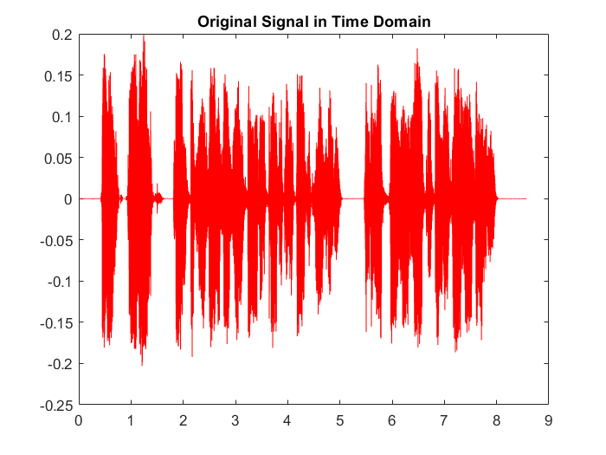

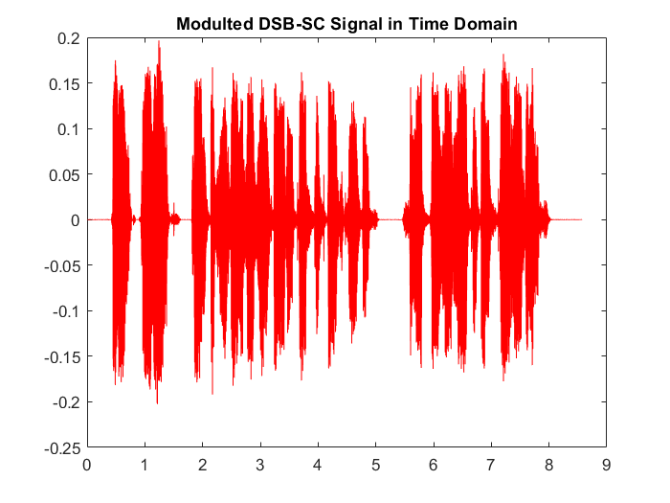

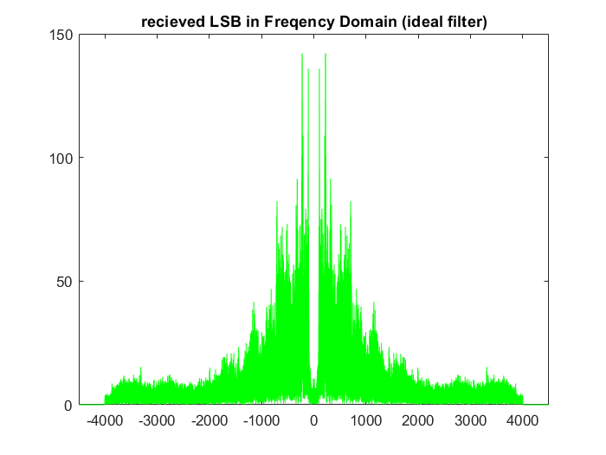

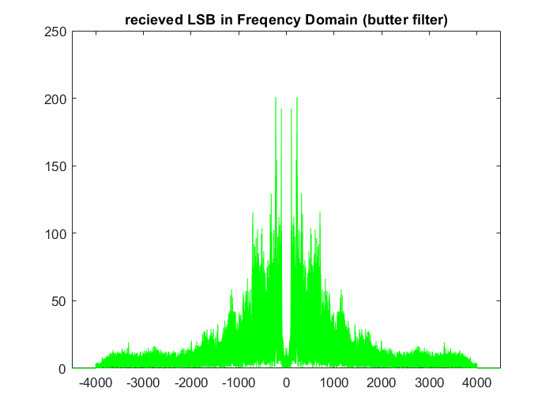

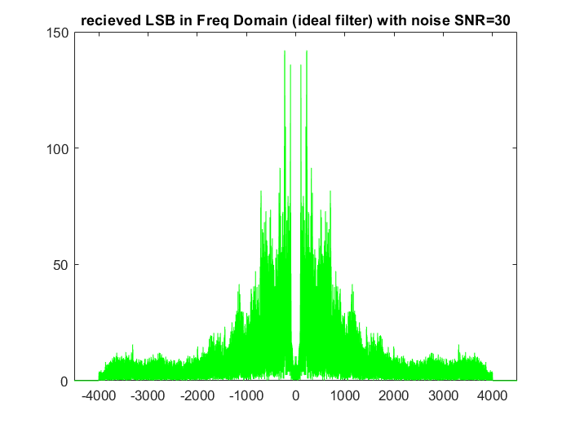

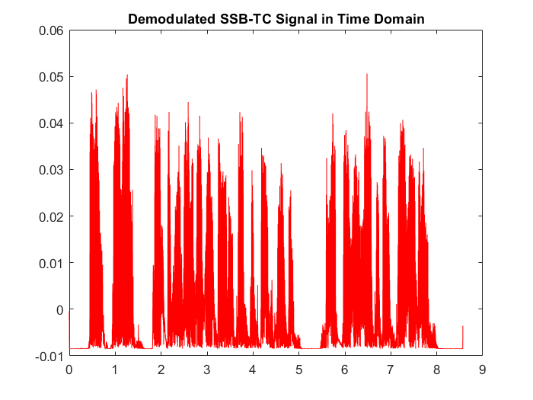

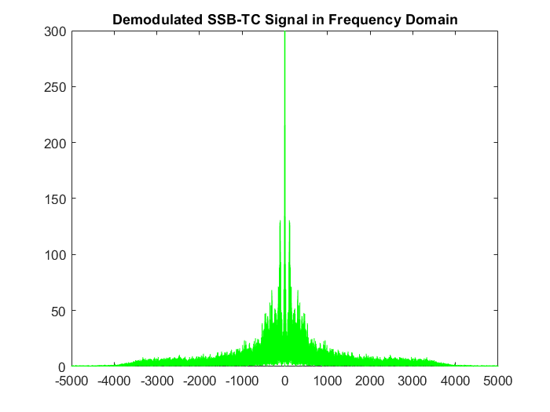

**Experiment 3:**

**Code:**

clc

clear

close all

**Read the audio file and get its sampling frequency**

[y, F] = audioread('eric.wav');

ty = length(y)/F;

t = linspace(0, ty, length(y));

**Input signal conversion to frequency domain (to apply ideal LPF)**

z = fftshift(fft(y));

f = linspace(-F/2, F/2, length(y));

figure

plot(f, abs(z),'g');

title('Original Signal in Frequency Domain');

**Searching for indices where f = -4000 and f = 4000**

for i = 1:length(f)

if (abs((f(i)+4.0000e+3)) < 0.01)

index1 = i;

end

if (abs((f(i)-4.0000e+3)) < 0.01)

index2 = i;

break;

end

end

% Generating a rect from index1 to index2

range = index2-index1;

step = [zeros(1, index1) ones(1, range) zeros(1, length(f)-index2)];

step = step.';

**Multiplying input signal by rect to eliminate frequencies other than 4k**

yfilteredFreq = step.*z;

yfilteredFreqAbs = abs(step.*z);

figure

plot(f, yfilteredFreqAbs,'g');

xlim([-15000 15000]);

title('Filtered Signal in Frequency Domain');

**Converting the filtered signal to time domain to be modulated**

yfiltered = ifft(fftshift(yfilteredFreq));

figure

plot(t, yfiltered,'r');

title('Filtered Signal in Time Domain');

**Signal after low pass filter**

sound(yfiltered, F);

pause(9);

**Filtered signal resampling**

maxAmplitude = max(yfiltered);

yfiltered = resample(yfiltered, 500000, F);

yfiltered = yfiltered.';

interval = length(yfiltered);

**Frequency Modulation**

**NBFM Signal**

kf = 1e+1*pi;

t = linspace(0, ty, interval);

deltaF = abs(kf*max(yfiltered));

m_int = kf.*cumsum(yfiltered);

nbfm = 2*maxAmplitude.*cos(2.*pi.*100000.*t + m_int);

figure

plot(t, nbfm,'r');

title('Modulted NBFM Signal in Time Domain');

zmnbfm = abs(fftshift(fft(nbfm)));

fmnbfm = linspace(-500000/2, 500000/2, length(nbfm));

figure

plot(fmnbfm, zmnbfm,'g');

title('Modulated NBFM Signal in Frequency Domain');

**Frequency Demodulation**

nbfm = diff(nbfm);

nbfmEnvelope = abs(hilbert(nbfm));

nbfmEnvelope = resample(nbfmEnvelope, F, 500000);

sound(nbfmEnvelope , F);

**output:**

**Experiment 3 Conclusions**

🡪When the instantaneous frequency increases the value of the

phase deviation increases.

🡪To achieve NBFM modulation index, frequency deviation, phase

deviation and frequency deviation constant are very small.